Name |  |  |  |  |  |  |  |  |  |  | Nickname |  |  |  | 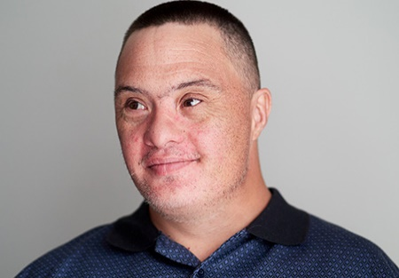
David Cook |  |  |  |  |  |  |  |  |  |  | Dave
Current Address
45 Shade Street, Treetop MA 00000
Former Address
25 Smith Street, Oldtown MA 00000
Sex | Race | D.O.B. |  | Age* | Height* |  | Weight* |  | Build |  |  | Hair |  | Eyes
M | Cauc | 3-15-64 |  | 52 | 6’1” |  | 196 |  |  |  |  | Br |  | Bl
Distinguishing Marks
Mole on right shoulder
Legal Competency Status
Presumed Competent
If Legal Guardian, Name |  |  |  |  |  |  |  |  |  | Phone
NA
Address |  |  |  |  |  |  |  |  |  | Work
Family Address (if different) |  |  |  |  |  |  |  |  |  | Phone
25 Smith Street |  |  |  |  |  |  |  |  |  | 617-000-0000
Oldtown MA 00000
Training / Work Program |  |  |  |  |  |  |  | Address |  |  |  |  |  |  |  |  |  | Phone
Amercare Services |  |  |  |  |  |  |  | 13 Main Street Treetop MA 00000 |  |  |  |  |  |  |  |  |  | 617-000-0000
Relevant Emergency Medical Information: (Allergies, Medications, etc.)
Allergies-none
Diagnoses-High blood pressure, osteoarthritis right knee, GERD
Physician’s Name |  |  |  |  |  |  |  | Address |  |  |  |  |  |  |  |  |  | Phone
Dr. Richard Black |  |  |  |  |  |  |  | 504 Lyman Street, Treetop MA 00000 |  |  |  |  |  |  |  |  |  | 617-000-0000
Language / Communication |  |  |  |  |  |  |  |  |  |  |  |  |  |  | Ability to protect self w/o assistance
Speaks and understands English
Minimal ability to read and write |  |  |  |  |  |  |  |  |  |  |  |  |  |  | yes
Significant Behavior Characteristics |  |  |  |  |  |  |  |  |  |  |  |  |  |  | Likely Response To Search Efforts
none |  |  |  |  |  |  |  |  |  |  |  |  |  |  | good
Pattern of Movement (if lost previously) |  |  |  |  |  | Places Frequented
Relevant Capabilities: |  |  |  |  |  |  | Limitations: |  |  |  |  |  |  |  | Preferences:
Independent with ADL’s |  |  |  |  |  |  |  |  |  |  |  |  |  |  | Enjoys riding on buses
Probable Dress*
Where and When the person was last seen |  |  |  |  |  |  |  |  |  |  |  |  |  |  | Date* |  |  |  | Time*
Emergency Contacts
FAMILY / GUARDIAN |  |  | David Cook, Sr. (father) |  |  |  |  |  |  |  |  |  | DDS |  |  |  | Sky Johnson, Service Coordinator
RESIDENCE |  |  | Linda White, Program Manager
Note: Asterisked (*) items are left blank on the original and filled in on copy if and when the individual is lost. Except age, height, and weight which must be recorded at all times on the form.
NAME |  |  |  |  |  |  | COMMONWEALTH OF MASSACHUSETTS |  |  |  |  |  |  |  |  | AREA
David Cook |  |  |  |  |  |  |  |  |  |  |  |  |  |  |  | Anywhere Area Office
RECORD LOCATION
45 Shade Street |  |  |  |  |  |  | EMERGENCY
Treetop MA 00000 |  |  |  |  |  |  | FACT SHEET

